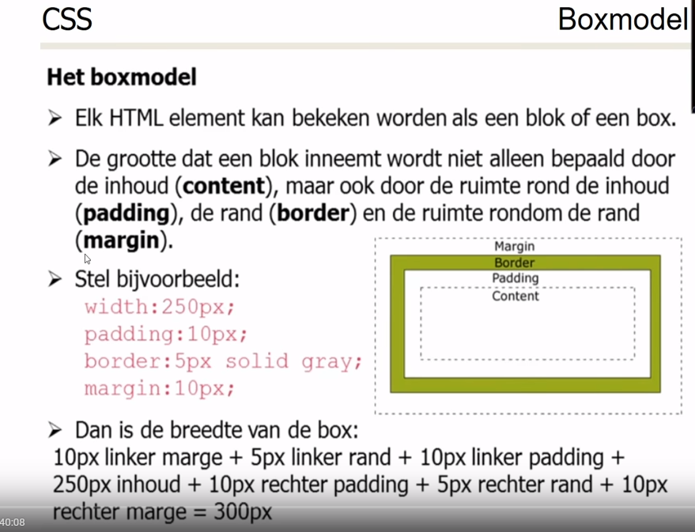

Cat photo app html+css plus classes en id
<link href="https://fonts.googleapis.com/css?family=Lobster" rel="stylesheet" type="text/css">
<style>
.red-text {
color: red;
}

h2 {
font-family: Lobster, monospace;
}

p {
font-size: 16px;
font-family: monospace;
}

.thick-green-border {
border-color: green;
border-width: 10px;
border-style: solid;
border-radius: 50%;
}

.smaller-image {
width: 100px;
}

.silver-background {
background-color: silver;
}
</style>

<h2 class="red-text">CatPhotoApp</h2>
<main>
<p class="red-text">Click here to view more <a href="#">cat photos</a>.</p>

<a href="#"><img class="smaller-image thick-green-border" src="https://bit.ly/fcc-relaxing-cat" alt="A cute orange cat lying on its back."></a>

<div class="silver-background">
<p>Things cats love:</p>
<ul>
<li>cat nip</li>
<li>laser pointers</li>
<li>lasagna</li>
</ul>
<p>Top 3 things cats hate:</p>
<ol>
<li>flea treatment</li>
<li>thunder</li>
<li>other cats</li>
</ol>
</div>

<form action="/submit-cat-photo" id="cat-photo-form">
<label><input type="radio" name="indoor-outdoor" checked> Indoor</label>
<label><input type="radio" name="indoor-outdoor"> Outdoor</label><br>
<label><input type="checkbox" name="personality" checked> Loving</label>
<label><input type="checkbox" name="personality"> Lazy</label>
<label><input type="checkbox" name="personality"> Energetic</label><br>
<input type="text" placeholder="cat photo URL" required>
<button type="submit">Submit</button>
</form>
</main>

Penguin animatie
<style>
:root {
--penguin-size: 200px;
--penguin-skin: black;
--penguin-belly: white;
--penguin-beak: orange;
}

@media (max-width: 350px) {
:root {

/* add code below */

/* add code above */

}
}

.penguin {
position: relative;
margin: auto;
display: block;
margin-top: 5%;
width: var(--penguin-size, 300px);
height: var(--penguin-size, 300px);
}

.right-cheek {
top: 15%;
left: 35%;
background: var(--penguin-belly, white);
width: 60%;
height: 70%;
border-radius: 70% 70% 60% 60%;
}

.left-cheek {
top: 15%;
left: 5%;
background: var(--penguin-belly, white);
width: 60%;
height: 70%;
border-radius: 70% 70% 60% 60%;
}

.belly {
top: 60%;
left: 2.5%;
background: var(--penguin-belly, white);
width: 95%;
height: 100%;
border-radius: 120% 120% 100% 100%;
}

.penguin-top {
top: 10%;
left: 25%;
background: var(--penguin-skin, gray);
width: 50%;
height: 45%;
border-radius: 70% 70% 60% 60%;
}

.penguin-bottom {
top: 40%;
left: 23.5%;
background: var(--penguin-skin, gray);
width: 53%;
height: 45%;
border-radius: 70% 70% 100% 100%;
}

.right-hand {
top: 5%;
left: 25%;
background: var(--penguin-skin, black);
width: 30%;
height: 60%;
border-radius: 30% 30% 120% 30%;
transform: rotate(130deg);
z-index: -1;
animation-duration: 3s;
animation-name: wave;
animation-iteration-count: infinite;
transform-origin:0% 0%;
animation-timing-function: linear;
}

@keyframes wave {
10% {
transform: rotate(110deg);
}
20% {
transform: rotate(130deg);
}
30% {
transform: rotate(110deg);
}
40% {
transform: rotate(130deg);
}
}

.left-hand {
top: 0%;
left: 75%;
background: var(--penguin-skin, gray);
width: 30%;
height: 60%;
border-radius: 30% 30% 30% 120%;
transform: rotate(-45deg);
z-index: -1;
}

.right-feet {
top: 85%;
left: 60%;
background: var(--penguin-beak, orange);
width: 15%;
height: 30%;
border-radius: 50% 50% 50% 50%;
transform: rotate(-80deg);
z-index: -2222;
}

.left-feet {
top: 85%;
left: 25%;
background: var(--penguin-beak, orange);
width: 15%;
height: 30%;
border-radius: 50% 50% 50% 50%;
transform: rotate(80deg);
z-index: -2222;
}

.right-eye {
top: 45%;
left: 60%;
background: black;
width: 15%;
height: 17%;
border-radius: 50%;
}

.left-eye {
top: 45%;
left: 25%;
background: black;
width: 15%;
height: 17%;
border-radius: 50%;
}

.sparkle {
top: 25%;
left:-23%;
background: white;
width: 150%;
height: 100%;
border-radius: 50%;
}

.blush-right {
top: 65%;
left: 15%;
background: pink;
width: 15%;
height: 10%;
border-radius: 50%;
}

.blush-left {
top: 65%;
left: 70%;
background: pink;
width: 15%;
height: 10%;
border-radius: 50%;
}

.beak-top {
top: 60%;
left: 40%;
background: var(--penguin-beak, orange);
width: 20%;
height: 10%;
border-radius: 50%;
}

.beak-bottom {
top: 65%;
left: 42%;
background: var(--penguin-beak, orange);
width: 16%;
height: 10%;
border-radius: 50%;
}

body {
background:#c6faf1;
}

.penguin * {
position: absolute;
}
</style>
<div class="penguin">
<div class="penguin-bottom">
<div class="right-hand"></div>
<div class="left-hand"></div>
<div class="right-feet"></div>
<div class="left-feet"></div>
</div>
<div class="penguin-top">
<div class="right-cheek"></div>
<div class="left-cheek"></div>
<div class="belly"></div>
<div class="right-eye">
<div class="sparkle"></div>
</div>
<div class="left-eye">
<div class="sparkle"></div>
</div>
<div class="blush-right"></div>
<div class="blush-left"></div>
<div class="beak-top"></div>
<div class="beak-bottom"></div>
</div>
</div>

Positionering

